**OTHER USEFUL LOCAL CONTACTS**

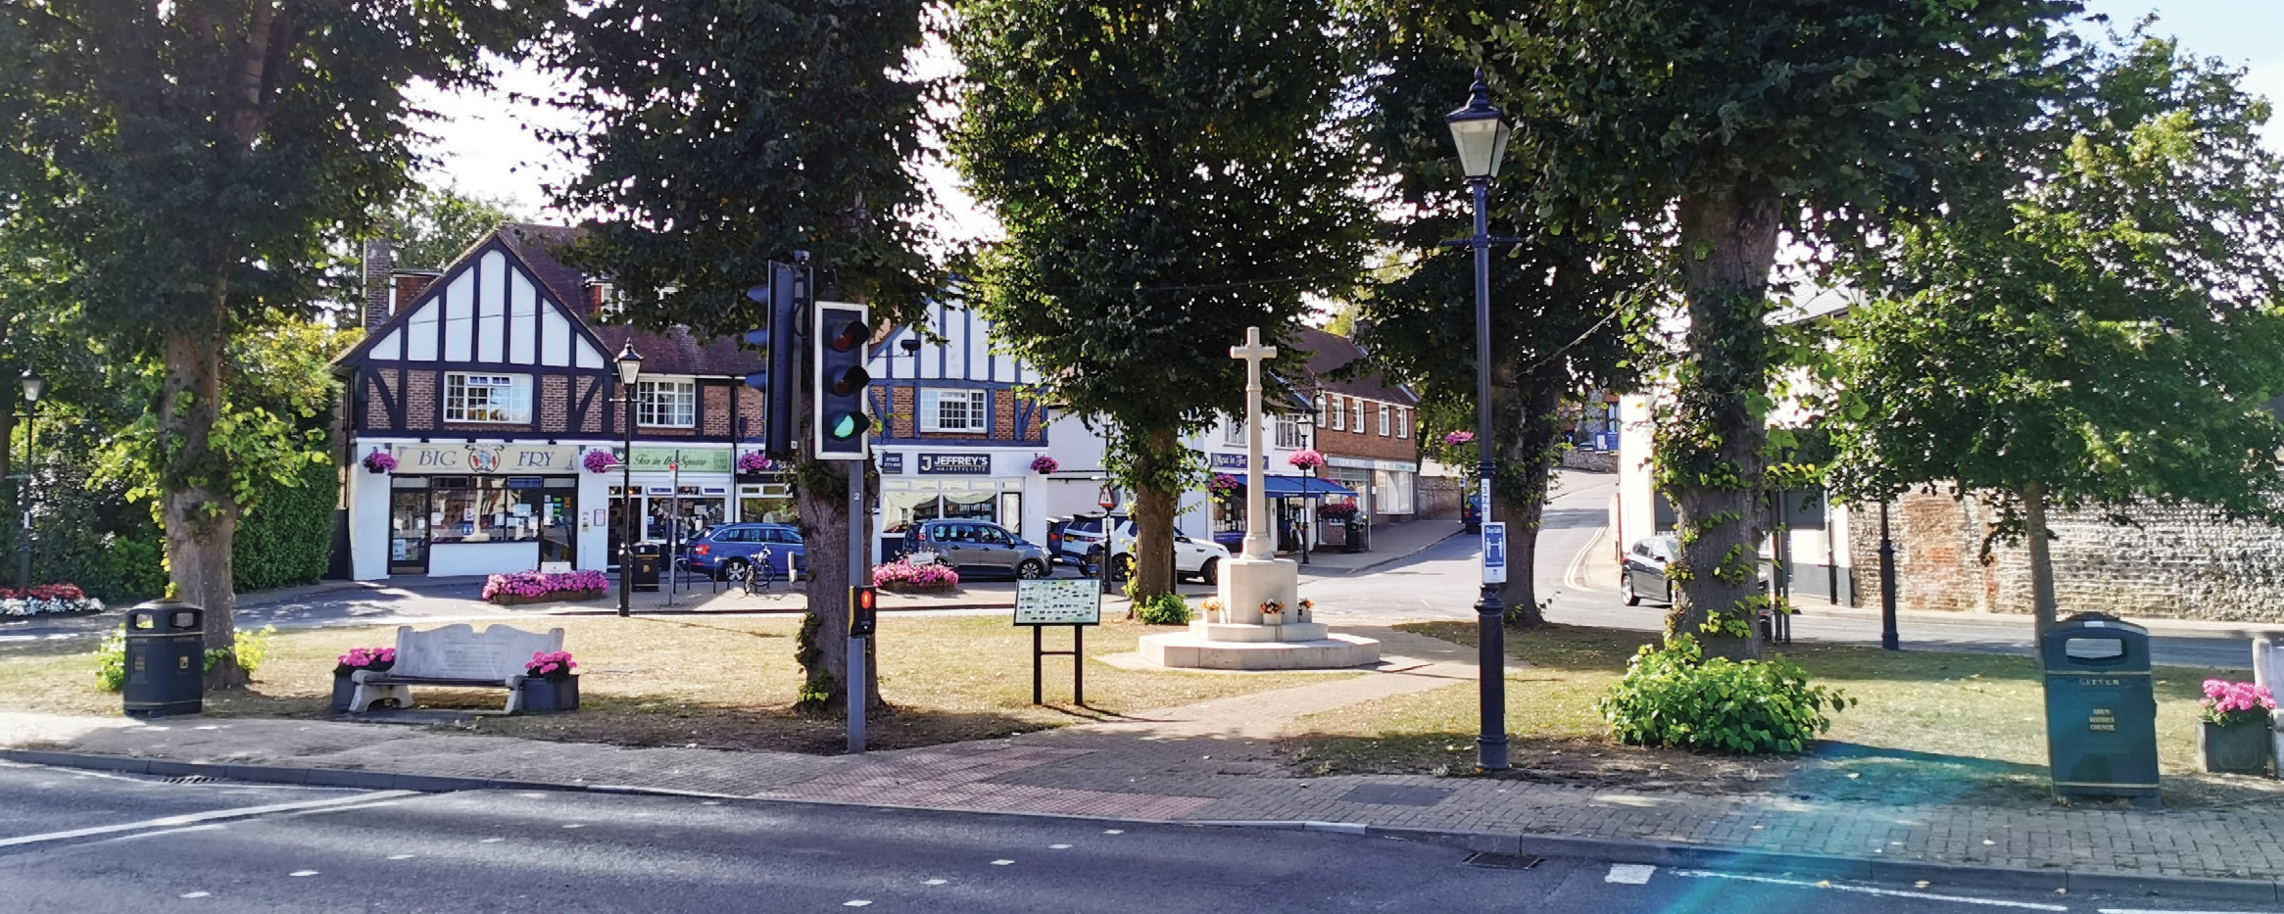

|  |  |  |
| --- | --- | --- |
| **Sussex Police** | 101 | [www.sussexpolice.uk](http://www.sussexpolice.uk) |
| **Crime Stoppers** | 0800 555 111 | [www.crimestoppers-uk.org](http://www.crimestoppers-uk.org) |
| **Community Speedwatch** |  | [csw@sussex.pnn.police.uk](mailto:csw@sussex.pnn.police.uk) |
| **Operation Crackdown**  Report anti-social driving  & abandoned vehicles. |  | [www.operationcrackdown.org](http://www.operationcrackdown.org) |
| **Street Communities**  Raise awareness of rough  sleepers |  | [www.streetlink.org.uk](http://www.streetlink.org.uk) |
| **Drug Litter**  Arun District Council | 01903 737754 | [cleansing@arun.gov.uk](mailto:cleansing@arun.gov.uk) |
| **Noise Nuisance**  Arun District Council | 01903 737755 | [www.arun.gov.uk/noise-polution](http://www.arun.gov.uk/noise-polution) |
| **Community Safety**  Arun District Council |  | [community.safety@arun.gov.uk](mailto:community.safety@arun.gov.uk) |
| **Causeway One Network**  Website for locating road works in the area |  | www.[Causeway one.network](https://one.network/) |

**ESSENTIAL LOCAL CONTACTS**

**Angmering Parish Council**

The Corner House, The Square, Angmering

West Sussex BN16 4EA

01903 772124

[admin@angmering-pc.gov.uk](mailto:admin@angmering-pc.gov.uk)

www.angmeringparishcouncil.gov.uk





# ARUN DISTRICT COUNCIL WEST SUSSEX COUNTY COUNCIL

**MAIN SWITCHBOARD:**

01903 737500 | [info@arun.gov.uk](mailto:info@arun.gov.uk)

Arun Civic Centre, Maltravers Road, Littlehampton, West Sussex BN17 5LF

|  |  |  |
| --- | --- | --- |
| **Emergency out of hours:** | 01903 737500 |  |
| **Planning & Building Control:** | 01903 737756 | [planning@arun.gov.uk](mailto:planning@arun.gov.uk) |
| **Planning Compliance:** [www.arun.gov.uk/planning-compliance/](http://www.arun.gov.uk/planning-compliance/) | | |
| **Housing & Housing benefit:** | 01903 737753 |  |
| **Car Parks:** | 01903 737655 | [Car.parks@arun.gov.uk](mailto:Car.parks@arun.gov.uk) |
| **Tree Preservation orders:** | 01903 737756 | [planning@arun.gov.uk](mailto:planning@arun.gov.uk) |
| **Parks and open spaces:** | 01903 737951 | [parks@arun.gov.uk](mailto:parks@arun.gov.uk) |
| **Licensing:** | 01903 737755 | [licensing@arun.gov.uk](mailto:licensing@arun.gov.uk) |
| **Rubbish, Recycling, Fly Tipping & Environmental Health:** | 01903 737754 | [cleansing@arun.gov.uk](mailto:cleansing@arun.gov.uk) |
| **Council tax and Business Rates:** | 01903 737752 | [revenues.benefits@arun.gov.uk](mailto:revenues.benefits@arun.gov.uk) |
| **Neighbourhood problems, antisocial behaviour & neighbourhood disputes:** | 0808 141 2800 | [asb@arun.gov.uk](mailto:asb@arun.gov.uk) |

Any maintenance matters regarding Fletchers Field and Palmer Road/

Decoy Drive Recreation Ground play parks please contact Arun District Council.

Your District Councillors are:

**Cllr. Paul Bicknell** [cllr.paul.bicknell@arun.gov.uk](mailto:cllr.paul.bicknell@arun.gov.uk)

**Cllr. Andy Cooper** [cllr.andy.cooper@arun.gov.uk](mailto:cllr.andy.cooper@arun.gov.uk)

**Cllr. Amelia Worne** cllr.amelia.worne@arun.gov.uk

**MAIN SWITCHBOARD:**

**01243 777100** | [**https://www.westsussex.gov.uk/**](https://www.westsussex.gov.uk/)

**County Hall, West Street, Chichester PO19 1RQ**

|  |  |
| --- | --- |
| **Roads & Highways -**  Potholes, parking, faulty streetlights, hedges, trees and any overgrown vegetation that causes a safety issue | www.westsussex.gov.uk/roads-and-travel/make-an-enquiry-or-report-a-problem-with-a-road-or-pavement/ |
| **Public Rights of Way (PROW)**  Footpaths/ bridle ways | www.westsussex.gov.uk/land-waste-and-housing/public-paths-and-the-countryside/public-rights-of-way/report-a-problem-with-a-right-of-way/ |
| **Education, Children and Families –**  School admissions, including Libraries | www.westsussex.gov.uk/education-children-and-families/ |
| **Blue Badges/Bus Passes** | www.westsussex.gov.uk/roads-and-travel/parking/the-blue-badge-scheme/ |
| **Births. Ceremonies and Deaths** | www.westsussex.gov.uk/births-ceremonies-and-deaths/ |

Your County Councillor is:

**Cllr. Deborah Urquhart:** [deborah.urquhart@westsussex.gov.uk](mailto:deborah.urquhart@westsussex.gov.uk)